OS Assignment-4

Q . Create a file named "data.txt" and write the following lines in it(write as it is).

Linux is open source.
In Linux everything is file
files have permissions.
files have inode no.
files have size.
there are several types of files

Ans 1.
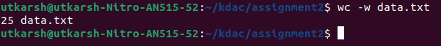

Ans 2.

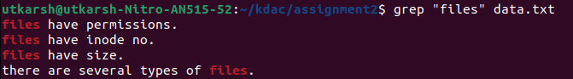

Ans 3.

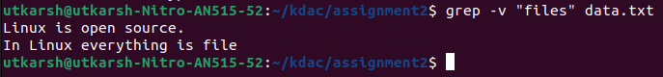

Ans 4.

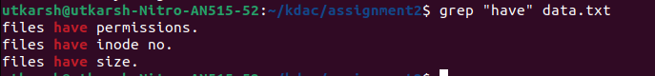

Ans 6.
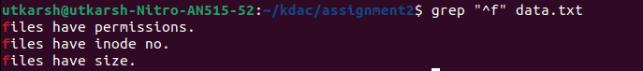

Ans 7.

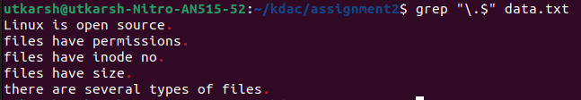

Ans 8.

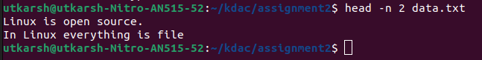

Ans 9.
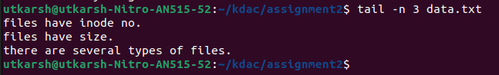

Ans 10.

